PRODUCTION (Electronics Systems)
DETAIL PRODUCTION PLAN : MONTH / YEAR:
JOB  ORDER  NO: | CUSTOMER  NAME | SYSTEM | QTY |  | OPERATIONS AND PLANNED DATE OF COMPLETION
 |  |  |  |  | MATERIAL | ASSEMBLY | WIRING | TESTING | LOAD CELL | FOR Q.C | REMARKS
 |  |  |  | PLANNED
 |  |  |  | ACTUAL
 |  |  |  | PLANNED
 |  |  |  | ACTUAL
 |  |  |  | PLANNED
 |  |  |  | ACTUAL
 |  |  |  | PLANNED
 |  |  |  | ACTUAL
 |  |  |  | PLANNED
 |  |  |  | ACTUAL
 |  |  |  | PLANNED
 |  |  |  | ACTUAL
 |  |  |  | PLANNED
 |  |  |  | ACTUAL
APPROVED BY HOD PDN

Form No. : R/PP-05/01/REV 00 Pg 1 of 1
JOB TRAVELLER CARD – PRODUCTION SYSTEMS

JOB No : CUSTOMER:
SYSTEM: QTY:
ASSEMBLY  Doc. No  Chassis Level  NAME:  Starting date & time:  Completion date & time:  signature:  Final assembly  NAME:  Starting date & time :  Completion date & time:  Feed back to design, If Any:  signature:  Inspected by: | REWORK
Reasons and Nature of
Rework
Carried out
By:

Time
Taken:

Inspected by:
Wiring  NAME:  Doc. No:  Starting date & time :  Completion date & time:  Feed back to design, If Any:  Signature:  Inspected by: |  | Carried out  By:  Time  Taken:  Inspected:
Testing  NAME:  Doc. No:  Starting date & time :  Completion date & time:  Given to Q.C. on:  Feed back to design, If Any:  Signature: |  | Carried out  By:  Time  Taken:  Inspected:
Note : In case of more than one rework use another form for the rework.

Form No. : R/PP-05/03/REV 02 Pg 1 of 1
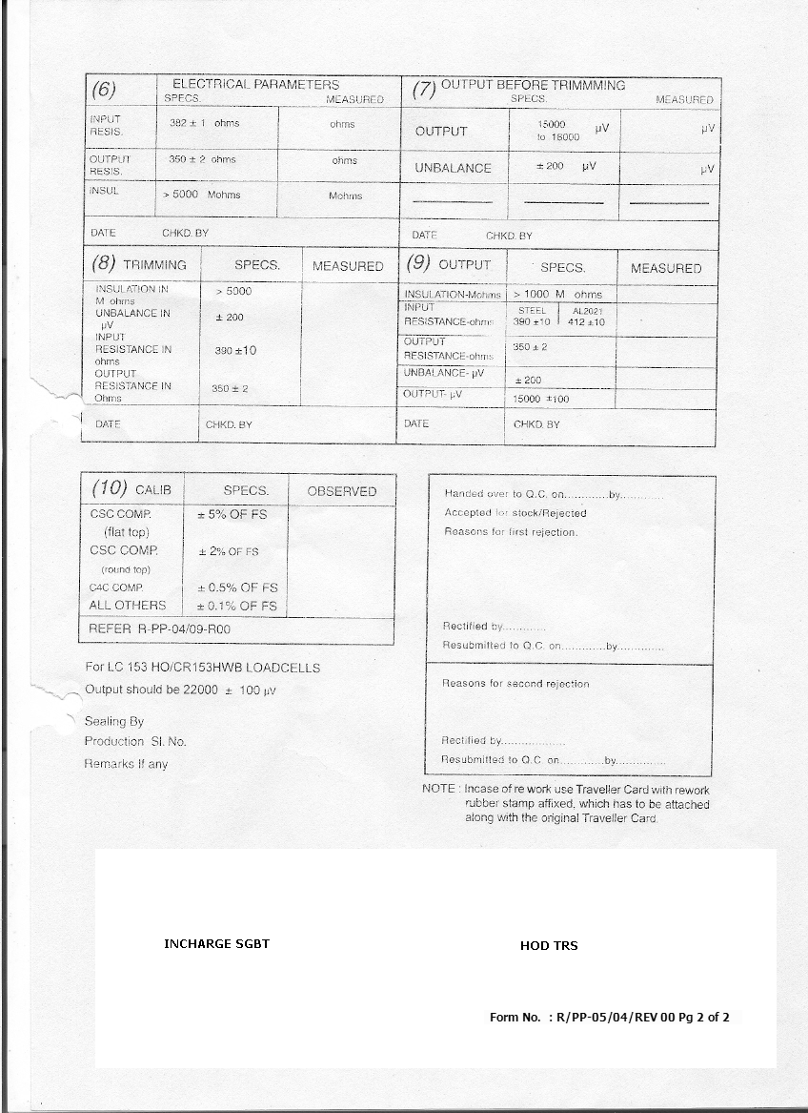
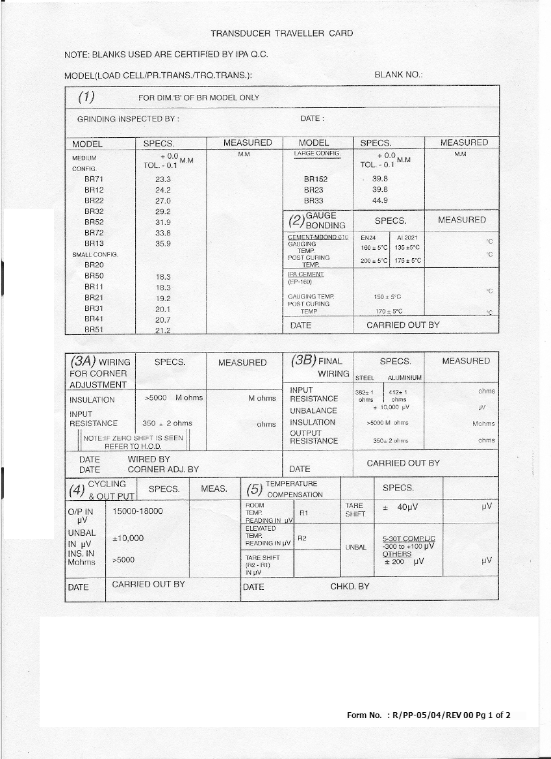

GENERAL ACCELEROMETER - JOB TRAVELLER

Model No………………………… Sl. No. ……………………………..

Customer ………………………… Job. Order No……………....Supply Date……………...

Crystal Details i) Batch………. (ii) Size – ID ……..mm, OD……….mm, Thickness……….mm

Weight of Accelerometer parts in gms. a) Mass………. b) Base………… c) Spring……………….

Total Weight………….. gms , Height…………….. mm , Spanner size ………………….mm

Resonant Frequency ………….Hz , Leakage Resistance…………MΩ , Capacitance…………..pF

Sl.  No. | Work Progress | Status | Work Done  By | Sig. | Date | Work  Insp.  by | Sig. | Date
1 | VISUAL INSPECTION  - Crystal Seating  - Spring Mechanical Play  - Finish
2 | Ultra – sonic Cleaning
3 | Connector Fixing
4 | Cleaning
5 | Lacquer Coating on Base Shaft
6 | Cleaning all parts for Assembly
7 | Crystal Assembly
8 | Preliminary Test
9 | Spring Sealing
10 | Calibration
11 | Cover seating
12 | Final Calibration

Charge Sensitivity of the Accelerometer…………………………….pC/g

Verified By: Approved By: (HOD, PDN)

Date:
Form No. : R/PP-05/05/REV 00 Pg 1 of 1

INDUSTRIAL ACCELEROMETER - JOB TRAVELLER

Model No………………………… Sl. No. ……………………………..
Customer ………………………… Job. Order No……………....Supply Date……………...
Crystal Details i) Batch………. (ii) Size – ID ……..mm, OD……….mm, Thickness……….mm
Weight of Accelerometer parts in gms. a) Mass………. b) Base………… c) Spring……………….
Total Weight………….. gms , Height…………….. mm , Spanner size ………………….mm
Resonant Frequency ………….Hz , Leakage Resistance…………MΩ , Capacitance…………..pF

Sl.  No. | Work Progress | Status | Work Done  By | Sig. | Date | Work  Insp.  by | Sig. | Date
1 | VISUAL INSPECTION  - Crystal Seating  - Spring Mechanical Play  - Finish
2 | Ultra – sonic Cleaning
3 | Connector Fixing
4 | Cleaning
5 | Lacquer Coating on Base Shaft
6 | Cleaning all parts for Assembly
7 | Crystal Assembly
8 | Preliminary Test
9 | Spring Sealing
10 | Pre – amplifier card assembly
11 | Calibration with card assembly
12 | Vibrating test at 10g for 15 mins.
13 | Cover seating
14 | Final Calibration

Voltage Sensitivity of the Accelerometer…………………………….mV/g

Verified By: Approved By:

Date: (HOD, PDN)

Form No. : R/PP-05/06/REV 00 Pg 1 of 1

ROUTINE TEST RECORD FOR LOAD / DIGITAL INDICATOR / TANK / HOPPER / SILO WEIGHING SYSTEM

SYSTEM :
JOB No. : CUSTOMER:
CAPACITY: Kg/Tonnes TAG. NO. :

Load/Digital  Indicator. | SENSOR | REMOTE  (IF ANY) | JUNCTION BOX
Model No.  Serial No. | Model No.  Serial No.  1)  2)  3)  4) | Model No.  Serial No. | Model No.  Serial No.  Model No.  Serial No.

Check for short between Line & Neutral ,
Neutral & Earth , Line & Earth :

SL.  No. | Test Performed | Specified Values | Actual Values
1. | Input Supply Voltage (+/-10%)
2. | Derived DC Voltages (+/-5%)  The voltages are measured with respect to Respective ground. | 5V(A)  -5V(A)  12V(A)  -12V(A)  5V(D)  24V(I)  12V(R)
3. | Check for the power on display and the Keyboard function.
4. | Load on the Load cell as specified in G.A. or MPL |  | Kg/T
5. | Tare weight as specified in G.A. or MPL |  | Kg/T

Resolution: L: kg/T

Measurement to be done from 0 to 110% of the System capacity.
Load on  Load cell  Kg/T or mV | Measured Load kg/T  (1 to 4 Load cell system)  1 2 3 4 |  |  |  | Current output  mA | Measured Load kg/T  (5 to 8 Load cell system)  5 6 7 8

Form No. : R/PP-05/07- LI/REV 01 Pg 1 of 2

ROUTINE TEST RECORD FOR LOAD / DIGITAL INDICATOR / TANK / HOPPER / SILO WEIGHING SYSTEM

SL.  No. | Test Performed | Checked :  YES/NO
6. | Relay Contacts: Check for the relay change over for the set points.
7. | Display Annuciation : (As per the software Details)
8. | RS 232 / RS 485 / BCD and Printer output (If any)  The RS232 / RS485 to be checked with  interfacing to PC  {Attach a printout along with the test report for the  Printer option }
9. | Any other parameters (If Any)
10. | Rating of the fuse used in the system :

REMARKS (If ANY):-

Instrument Used:

Tested by: Approved by:
Date: (HOD – PDN)

Form No. : R/PP-05/07- LI/REV 01 Pg 2 of 2

ROUTINE TEST RECORD FOR WEIGH FEEDER

JOB No. : CUSTOMER:
CAPACITY : TPH CONVEYOR NO:

WEIGH FEEDER | SENSOR | TACHO / PROXIMITY | JUNCTION BOX
Model No.  Serial No.  LOCAL PANEL:  Model No.  Serial No. | Model No.  Serial No.  1)  2)  3)  4) | AC / Pulse  Model No.  Serial No. | Model No.  Serial No.  Model No.  Serial No.

Ac/Dc drive  Details | Make: Capacity: Kw.  Serial No. :

Check for short between Line & Neutral ,
Neutral & Earth , Line & Earth :

SL.  No. | Test Performed | Specified Values | Actual Values
1. | Input Supply Voltage (+/-10%)
2. | Derived DC Voltages (+/-5%)  The voltages are measured with respect to Respective ground. | 5V(A)  -5V(A)  12V(A)  -12V(A)  5V(D)  24V(I)  12V(R)  15V(T)
3. | Check for the power on display and the Keyboard function.
4. | Belt Load as specified in G.A. or MPL |  | Kg/m
5. | Belt Speed as specified in G.A. or MPL |  | m/s

Resolution: L: kg/m S: m/s r: tph t: tonnes

Measurement to be done from 10 to 100% of the Feeder capacity.
I).
Belt Length | mm.
Actual speed (Measured with stop clock ) | m/s

II). Speed calibration: Calibrate the speed by entering the actual belt speed when the Drive output is 100%.
Drive output in  % | Actual Speed  m/s | Measured Speed  m/s
10
25
50
75
100

Form No. : R/PP-05/07-WF/REV 00 Pg 1 of 2

ROUTINE TEST RECORD FOR WEIGH FEEDER

III). Load Calibration: Chain Weight: Kg/m Cal. Rod weight: Kg.

IV). VOLUMETRIC MODE: Control shall be less than 0.5 % of the F.S.

Set Speed  m/s |  | Measured Speed  m/s
 |  | Min | Max | Avg. | % Error
10%
25%
50%
75%
100%

V). GRAVIMETRIC MODE: Set rate control shall be less than 0.5% of F.S.

Set rate  tph |  | Measured rate  tph  Min Max Avg | Belt  Load  Kg/m | Totalizer ( 6 min) |  | %  Error | Current  O/p  mA
 |  | Measured rate  tph  Min Max Avg | Belt  Load  Kg/m | Act. | Meas. | %  Error | Current  O/p  mA
10%
25%
50%
75%
100%

Check for the external input response
For the set rate , Digital Input and
Outputs , Communication etc.

Remarks:

Instrument Used:

Tested by: Approved by:
Date: (HOD – PDN)

Form No. : R/PP-05/07-WF/REV 00 Pg 2 of 2

ROUTINE TEST RECORD FOR BELT SCALE

JOB No. : CUSTOMER:
CAPACITY : TPH CONVEYOR NO:
BELT SCALE | SENSOR | TACHO | JUNCTION BOX
Model No.  Serial No.  REMOTE:  Model No.  Serial No. | Model No.  Serial No.  1)  2)  3)  4) | AC / Pulse/Proximity Sensor  Model No.  Serial No.  Rpm : N = S/3.14 * D =  S Belt Speed in m/s.  D Wheel dia in mts. | Model No.  Serial No.  Model No.  Serial No.

Check for short between Line & Neutral ,
Neutral & Earth , Line & Earth :

SL.  No. | Test Performed | Specified Values | Actual Values
1. | Input Supply Voltage (+/-10%)
2. | Derived DC Voltages (+/-5%)  The voltages are measured with respect to Respective ground. | 5V(A)  -5V(A)  12V(A)  -12V(A)  5V(D)  24V(I)  12V(R)  15V(T)
3. | Check for the power on display and the Keyboard function.
4. | Belt Load as specified in G.A. or MPL |  | Kg/m
5. | Belt Speed as specified in G.A. or MPL |  | m/s

Resolution: L: kg/m S: m/s r: tph t: tonnes
Measurement to be done from 0 to 110% of the Belt Scale capacity.
Load on  Load cell  kg | Belt load  Kg/m | Speed in  m/s | Rate in  tph | Totalizer in  Tones (6 min) | O/p current  mA

Instrument Used:

Tested by: Approved by:
Date: (HOD – PDN)

Form No. : R/PP-05/07-BS/REV 00 Pg 1 of 2

ROUTINE TEST RECORD FOR REMOTE INDICATOR

JOB No. : CUSTOMER:
CAPACITY : TPH:

RS 485 CONNECTION TO BE MADE AS PER WIRING DIAGRAM ENCLOSED WITH MASTER PAR LIST.

Check for short between Line & Neutral ,
Neutral & Earth , Line & Earth :

SL.  No. | Test Performed | Specified Values | Actual Values
1. | Input Supply Voltage (+/-10%)
2. | Derived DC Voltages (+/-5%)  The voltages are measured with respect to Respective ground. | 5V(D)  5V (I)
3. | Check for the power on display and the Keyboard function.

Measurement to be done from 0 to 110% of the Belt Scale capacity.

Rate in tph | Totalizer in  tonnes

Instrument Used:

Tested by: Approved by:
Date: (HOD – PDN)

Form No. : R/PP-05/07-RBS/REV 00 Pg 2 of 2

ROUTINE TEST RECORD FOR LOCAL PANEL

JOB No. : CUSTOMER:
CAPACITY : TPH
MODEL NO. :
SERIAL NO. :

RS 485 CONNECTION TO BE MADE AS PER WIRING DIAGRAM ENCLOSED WITH MASTER PAR LIST.

Check for short between Line & Neutral ,
Neutral & Earth , Line & Earth :

SL.  No. | Test Performed | Specified Values | Actual Values
1. | Input Supply Voltage (+/-10%)
2. | Derived DC Voltages (+/-5%)  The voltages are measured with respect to Respective ground. | 5V(D)  5V (I)
3. | Check for the power on display and the Keyboard function.
4. | Test for input command belt on. Belt off , Emergency off etc.

Measurement to be done from 0 to 110% of the Full Scale capacity.

Rate in tph | Totalizer in  Tonnes

Instrument Used:

Checked by: Approved by:
Date: (HOD – PDN)

Form No. : R/PP-05/07-LP/REV 00 Pg 1 of 1

ROUTINE TEST RECORD FOR WINTER

JOB No. : CUSTOMER:
CAPACITY : Kg/Tonnes STAMP. :

Load/Digital  Indicator. | SENSOR | REMOTE  (IF ANY) | JUNCTION BOX
Model No.  Serial No. | Model No.  Serial No.  1)  2)  3)  4) | Model No.  Serial No. | Model No.  Serial No.  Model No.  Serial No.

Check for short between Line & Neutral ,
Neutral & Earth , Line & Earth :

SL.  No. | Test Performed | Specified Values | Actual Values
1. | Input Supply Voltage (+/-10%)
2. | Derived DC Voltages (+/-5%)  The voltages are measured with respect to Respective ground.  Battery voltages (3.6 V +/- 10%)  Memory card. | 5V(A)  -5V(A)  12V(A)  -12V(A)  5V(D)  3.6V
3. | Check for the power on display and the Keyboard function.
4. | Load on the Load cell as specified in MPL |  | Kg/T
5. | Platform type (Dual or Single)

Resolution: L: kg/T

Measurement to be done from 0 to 100% of the System capacity.
Load on  the  Load cell  Kg/T or mV | 1 2 3 4 5 6 7 8
  Measured Load kg/T

Form No. : R/PP-05/07-WI/REV 00 Pg 1 of 2

ROUTINE TEST RECORD FOR WINTER

SL.  No. | Test Performed | Checked :  YES/NO
6. | Relay Contacts: Check for the relay change over for the set points.
7. | Display Annuciation : (As per the software Details)
8. | RS 232 / RS 485 / BCD and Printer output (If ANY)  {The RS232 / RS485 to be checked with  interfacing to PC and use the software  ProComm or software which is to be supplied}  {Attach a printout along with the test report for the  Printer option }
9. | Any other parameters (If Any)
10. | Rating of the fuse used in the system :

REMARKS (If ANY):-

Instrument Used:

Checked by: Approved by: (HOD – PDN)
Date:

Form No. : R/PP-05/07-WI/REV 00 Pg 2 of 2

TEST RECORD FOR TRIP SAFE

JOB OREDR No. :
CUSTOMER:

TRIPSAFE LOAD CELL:

MODEL NO. : MODEL NO. :
SERIAL NO. : SERIAL NO :

Calibration chart for a load input / mV input :

SL.NO. | LOAD INPUT IN  ACHIEVED |  | TRIP SAFE LEVEL  ACHIEVED IN |  | FACTORY SET LEVEL | LEVEL
SL.NO. | Kg/T | % | Kg/T | % | FACTORY SET LEVEL | LEVEL

Percentage of error:

PF Contact for Healthy / Over Load:

Lamp indication / LED anauciation as applicable:

Instrument Used:

Tested by: Approved by:
Date: (HOD – PDN)

Form No. : R/PP-05/07-TS/REV 01 Pg 1 of 1

ROUTINE TEST RECORD FOR CRANE SCALE

JOB No. : CUSTOMER:
CAPACITY : Kg/ Tonnes STAMP NO:
Load cell. Model No. : Serial No. :

Crane scale | Battery charger | Hook | Bow shackle
Model No.  Serial No. | ModelNo: QBC 121SR  Sl.No: | Sl.No | Sl.No:

SL.  No. | Test Performed | Specified Values | Actual Values
1. | Input Battery Voltage ( For 12V ) | 10.5V to 13.6V
2. | Derived DC Voltages (+/-5%) | 5V
3. | Check for the power on display, Remote and the Keyboard function.

Resolution : L: kg/tonnes

Measurement to be done from 0 to 100% of the Crane Scale capacity.
Load on  Load cell  Kg/T or mv | Measured load  Kg/T

- Battery Charger voltage
When the battery connected:

- Low battery voltage set (CS):

- Check for the remote operation:
(For the distance of min. 10 meters)

Remote
Model No: RC500A0
Sl. No:

Calibrator
Model No: CC500A0
Sl.No:

Instrument Used:

Checked by: Approved by:
Date: (HOD – PDN)

Form No. : R/PP-05/07-CS/REV 01 Pg 1 of 1

TEST RECORD FOR SIGNAL CONDITIONER

JOB OREDR No. :
CUSTOMER:

SIGNAL CONDITIONER LOAD CELL

MODEL NO. : MODEL NO. :
SERIAL NO. : SERIAL NO. :

Calibration chart for a load input / mV input :

SL.NO. | LOAD ON LOAD CELL  Kg/T OR mV | OUTPUT IN  CURRENT / VOLTAGE

Percentage of error:

Multimeter Used:

Tested by: Approved by:
Date: (HOD – PDN)

Form No. : R/PP-05/07-SC/REV 00 Pg 1 of 1

ROUTINE TEST RECORD FOR BATCHING SYSTEM

JOB No. : CUSTOMER:
CAPACITY : Kg/Tonnes

BATCHING SYSTEM  (BWS SERIES) | DIGITAL INDICATOR  (WH) | LINE DRIVER | JUNCTION BOX
Model No.  Serial No. | Model No.  Serial No. | Model No.  Serial No. | Model No.  Serial No.  Model No.  Serial No.
SENSOR | PLC MAKE | EXPANSION MODULE
Model No.  Serial No.  1)  2)  3)  4) | Model No.  Serial No. | Digital Module:  QTY. :  Analog Module:

Check for short between Line & Neutral ,
Neutral & Earth , Line & Earth :

SL.  No. | Test Performed | Specified Values | Actual Values
1. | Input Supply Voltage (+/-10%)
2. | Derived DC Voltages (+/-5%)  The voltages are measured with respect to Respective ground. | 5V(A)  -5V(A)  12V(A)  -12V(A)  5V(D)  24V(I)
3. | Check for the power on display, annunciation and the Keyboard function.

Resolution: L: kg/T
Measurement to be done from 0 to 110% of the Batching system capacity.
Load on  Load cell  Kg/T or mV | Measured Load  Kg/T 1 to 4 L/C SYS.  WH1 WH2 WH3 WH4 |  |  |  | Current output  mA

Form No. : R/PP-05/07-BCH/REV 00 Pg 1 of 2

ROUTINE TEST RECORD FOR BATCHING SYSTEM

SL.  No. | Test Performed | Checked :  Yes/No
4. | Functional check  - Manual Mode  - Semi Auto Mode  - Auto Mode
5. | PF contacts to customer
6. | PF contacts from limit switches
7. | PF contacts for annunciation
8. | Controls on horizontal desk
9. | 4-20mA current output
10. | PC software (SCADA)
11. | Communications
12. | Any Other Parameter(If Any)
13. | REMARKS (IF ANY)

Instrument Used:

Tested by: Approved by:
Date: (HOD – PDN)

Form No. : R/PP-05/07-BCH/REV 00 Pg 2 of 2

PERFORMANCE INDEX

MONTH | No. OF JOBS SCHEDULED | No. OF JOBS COMPLETED | % ACHEIVED
Jun 14  Jul 14  Aug 14  Sep 14  Oct 14  Nov 14  DEC 15  JAN 15  FEB 15  MAR 15  APR 15  May 15  Jun 15  Jul 15  Aug 15  Sep 15  Oct 15 | 57  61  6567  106  80  102  72  78  73  84  66  85  85  87  76  86 | 52  65  57  94  72  93  63  65  '  59  80  55  73  74  81  65  77 | 91.2%  91.8%  85.1%  88.7%  90%  88%  87.5%  83.3%  80.8%  95.3%  83.3%  85.9%  87.0%  93.1%  85.5%  89.5%

Prepared by :

(HOD PDN)

Form No. : R/PP-05/08/REV 01 Pg 1 of 1

ACCELEROMETER TEST RECORD

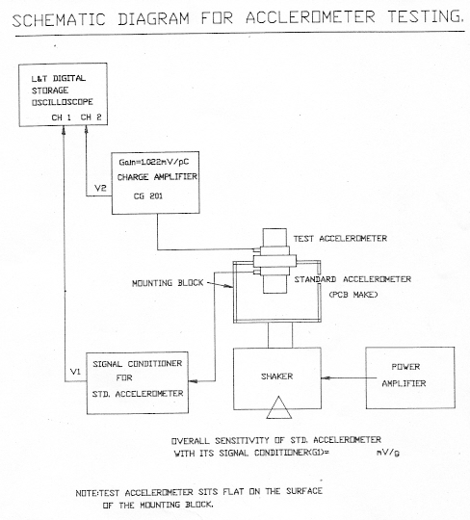

TESTED BY: APPROVED BY:
DATE : HOD – TRS

Form No. : R/PP-05/09-ACC/REV 00 Pg 2 of 8

ACCELEROMETER TEST RECORD

Model No……………… Sl.No………………………..
Test I Axial Sensitivity

Overall sensitivity of Std. Accelerometer and its Sig. Cond. = 43.18 mV/g
Gain of Charge amplifier (G2) = 1.022 mV/pC
Acceleration Setting Tol : +/- 10% of set value

- Frequency : 50 – 60 Hz
Acceleration: (2, 4, 8, 10, 20 & 40) * (1/9.81) g – pk-pk

Freq.  (Hz) | O/P of std.  Accl.  V1(pk-pk)mV | O/P of test  Accl.  V2(pk-pk)mV | V2¹ =  (V2/G2)  mV | Acceleration  A= (V1)/50.102 | Sensitivity  S=  (V2¹)/A pC/g

- Frequency : 50–60,100-200,300-400,700-800,1K-2K,2K-3K (Hz)
  - A= 2 * (1/9.81) g pk-pk

Freq.  (Hz) | O/P of std.  Accl.  V1(pk-pk)mV | O/P of test  Accl.  V2(pk-pk)mV | V2¹ =  (V2/G2)  mV | Acceleration  A= (V1)/50.102 | Sensitivity  S=  (V2¹)/A pC/g

Mean = pC/g

TESTED BY: APPROVED BY:

DATE HOD – PDN

Form No. : R/PP-05/09-ACC/REV 01 Pg 2 of 3

ACCELEROMETER TEST RECORD

Model No……………… Sl.No………………………..
Test I . (b) contd.
Frequency : 50–60,100-200,300-400,700-800,1K-2K,2K-3K (Hz)
  - A= 4 * (1/9.81) g pk-pk
Freq.  (Hz) | O/P of std.  Accl.  V1(pk-pk)mV | O/P of test  Accl.  V2(pk-pk)mV | V2¹ =  (V2/G2)  mV | Acceleration  A= (V1)/50.102 | Sensitivity  S=  (V2¹)/A pC/g
Mean = pC/g

  - A= 8 * (1/9.81) g pk-pk
Freq.  (Hz) | O/P of std.  Accl.  V1(pk-pk)mV | O/P of test  Accl.  V2(pk-pk)mV | V2¹ =  (V2/G2)  mV | Acceleration  A= (V1)/50.102 | Sensitivity  S=  (V2¹)/A pC/g
Mean = pC/g
  - A= 10 * (1/9.81) g pk-pk
Freq.  (Hz) | O/P of std.  Accl.  V1(pk-pk)mV | O/P of test  Accl.  V2(pk-pk)mV | V2¹ =  (V2/G2)  mV | Acceleration  A= (V1)/50.102 | Sensitivity  S=  (V2¹)/A pC/g
Mean = pC/g

TESTED BY: APPROVED BY:

DATE: HOD – TRS

Form No. : R/PP-05/09-ACC/REV 00 Pg 4 of 8
ACCELEROMETER TEST RECORD

Model No……………… Sl.No………………………..
Test I . (b) contd.
Frequency : 50–60,100-200,300-400,700-800,1K-2K,2K-3K (Hz)
  - A= 20 * (1/9.81) g pk-pk

Freq.  (Hz) | O/P of std.  Accl.  V1(pk-pk)mV | O/P of test  Accl.  V2(pk-pk)mV | V2¹ =  (V2/G2)  mV | Acceleration  A= (V1)/50.102 | Sensitivity  S=  (V2¹)/A pC/g
Mean = pC/g

  - A= 40 * (1/9.81) g pk-pk

Freq.  (Hz) | O/P of std.  Accl.  V1(pk-pk)mV | O/P of test  Accl.  V2(pk-pk)mV | V2¹ =  (V2/G2)  mV | Acceleration  A= (V1)/50.102 | Sensitivity  S=  (V2¹)/A pC/g
Mean = pC/g

Change sensitivity= pC/g

TESTED BY: APPROVED BY:

DATE HOD – TRS

Form No. : R/PP-05/09-ACC/REV 00 Pg 5 of 8

ACCELEROMETER TEST RECORD

Model No……………… Sl.No………………………..
Test II Transverse Sensitivity

Overall sensitivity of Std, Accelerometer and its Sig. Cond. = 50.102 mV/g
Gain of Charge amplifier (G2) = 1.022 mV/pC
Acceleration Setting Tol : +/- 10% of set value

- A= 2 * (1/9.81) g pk-pk Frequency shall be 50 +/- 2 Hz

Freq.  (Hz) | O/P of std.  Accl.  V1(pk-pk)mV | O/P of test  Accl.  V2(pk-pk)mV | V2¹ =  (V2/G2)  mV | Acceleration  A= (V1)/50.102 | Sensitivity  S=  (V2¹)/A pC/g | %=  (SX100)/  Avg. ‘S’
Mean = %

- A= 4 * (1/9.81) g pk-pk Frequency shall be 50 +/- 2 Hz

Freq.  (Hz) | O/P of std.  Accl.  V1(pk-pk)mV | O/P of test  Accl.  V2(pk-pk)mV | V2¹ =  (V2/G2)  mV | Acceleration  A= (V1)/50.102 | Sensitivity  S=  (V2¹)/A pC/g | %=  (SX100)/  Avg. ‘S’
Mean = %

- A= 8 * (1/9.81) g pk-pk Frequency shall be 50 +/- 2 Hz

Freq.  (Hz) | O/P of std.  Accl.  V1(pk-pk)mV | O/P of test  Accl.  V2(pk-pk)mV | V2¹ =  (V2/G2)  mV | Acceleration  A= (V1)/50.102 | Sensitivity  S=  (V2¹)/A pC/g | %=  (SX100)/  Avg. ‘S’
Mean = %

TESTED BY: APPROVED BY:

DATE HOD – TRS

Form No. : R/PP-05/09-ACC/REV 00 Pg 6 of 8

ACCELEROMETER TEST RECORD

Model No……………… Sl.No………………………..
Test II Contd.

- A= 10 * (1/9.81) g pk-pk Frequency shall be 50 +/- 2 Hz

Freq.  (Hz) | O/P of std.  Accl.  V1(pk-pk)mV | O/P of test  Accl.  V2(pk-pk)mV | V2¹ =  (V2/G2)  mV | Acceleration  A= (V1)/50.102 | Sensitivity  S=  (V2¹)/A pC/g | %=  (SX100)/  Avg. ‘S’
Mean = %

- A= 20 * (1/9.81) g pk-pk Frequency shall be 50 +/- 2 Hz

Freq.  (Hz) | O/P of std.  Accl.  V1(pk-pk)mV | O/P of test  Accl.  V2(pk-pk)mV | V2¹ =  (V2/G2)  mV | Acceleration  A= (V1)/50.102 | Sensitivity  S=  (V2¹)/A pC/g | %=  (SX100)/  Avg. ‘S’
Mean = %

- A= 40 * (1/9.81) g pk-pk Frequency shall be 50 +/- 2 Hz

Freq.  (Hz) | O/P of std.  Accl.  V1(pk-pk)mV | O/P of test  Accl.  V2(pk-pk)mV | V2¹ =  (V2/G2)  mV | Acceleration  A= (V1)/50.102 | Sensitivity  S=  (V2¹)/A pC/g | %=  (SX100)/  Avg. ‘S’
Mean = %

Transverse sensitivity= %

TESTED BY: APPROVED BY:

DATE HOD – TRS

Form No. : R/PP-05/09-ACC/REV 00 Pg 7 of 8

ACCELEROMETER TEST RECORD

Model No……………… Sl.No………………………..

Test III Post Sealing Axial Sensitivity

Overall sens. of Std. Accelerometer and its Sig. Cond.(G1) = 43.18 mV/g
Gain of Charge amplifier (G2) = 1.022 mV
Acceleration Setting Tol : +/- 10% of set value

Frequency : 50 – 60 Hz

Acceleration: (2, 4, 8, 10, 20 & 40) * (1/9.81) g – pk-pk

Freq.  (Hz) | O/P of std.  Accl.  V1(pk-pk)mV | O/P of test  Accl.  V2(pk-pk)mV | V2¹ =  (V2/G2)  mV | Acceleration  A= (V1)/G1 | Sensitivity  S=  (V2¹)/A pC/g

TESTED BY: APPROVED BY:

DATE: HOD – (PDN)

Form No. : R/PP-05/09-ACC/REV 01 Pg 3 of 3

VIBRATION METER TEST RECORD

Model No……………… Sl.No………………………..

POINTS | 1 | 2 | 3 | 4 | 5 | 6 | 7 | 8 | 9 | 10
EXPECTED  DC VOLTAGE (V) | 1<=V<=4 | 1<=V<=4 | ± 1 V | ± 20 mV | ± 2 mV | ± 5 mV | ± 10 mV | ± 10 mV | ± 1 mV | ± 2 mV
OBTAINED
DC VOLTAGE (V)

TESTED BY: APPROVED BY: HOD – PDN

DATE

Form No. : R/PP-05/10-VM/REV 00 Pg 2 of 6

VIBRATION METER TEST RECORD

Model No……………… Sl.No………………………..
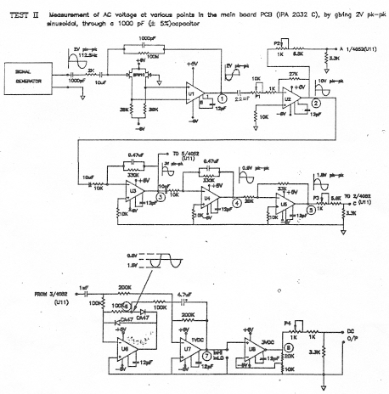

TESTED BY: APPROVED BY: HOD – PDN
POINTS | 1 | 2 | 3 | 4 | 5 | 6 | 7 | 8
EXPECTED  AC VOLTAGE  ± 5% | 2 V p-p | 10V p-p | 3V p-p | 0.5V p-p | 1.5 V p-p | 0.6 V  1.8V | 1 V DC | 3 V DC
OBTAINED
AC VOLTAGE

DATE

Form No. : R/PP-05/10-VM/REV 00 Pg 3 of 6

VIBRATION METER TEST RECORD

Model No……………… Sl.No………………………..

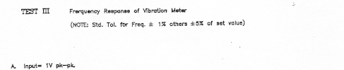
Freq.  Hz | Accl.  (peak  m/sec² ) | Vel.(rms)  Cm/sec  Cal.val. | Vel.(rms)  Cm/sec  Meas.val. | %  Error | Disp mm  pk-pk  cal.val. | Disp mm  pk-pk  Meas.val. | %  Error
1
2
5
10
20
50
71.17
100
112.5
200
500
1K
2K
3K
5K
10K
20K
100K

TESTED BY: APPROVED BY: HOD – PDN

DATE

Form No. : R/PP-05/10-VM/REV 00 Pg 4 of 6

VIBRATION METER TEST RECORD

Model No……………… Sl.No………………………..
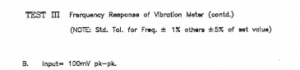

Freq.  Hz | Accl.  (peak  m/sec² ) | Vel.(rms)  Cm/sec  Cal.val. | Vel.(rms)  Cm/sec  Meas.val. | %  Error | Disp mm  pk-pk  cal.val. | Disp mm  pk-pk  Meas.val. | %  Error
50
20
10

Freq.  Hz | Accl.  (peak  m/sec² ) | Disp mm  pk-pk  cal.val. | Disp mm  pk-pk  Meas.val. | %  Error
50

TESTED BY: APPROVED BY: HOD – PDN

DATE

Name Signature Designation

Form No. : R/PP-05/10-VM/REV 00 Pg 5 of 6

VIBRATION METER TEST RECORD

Model No……………… Sl.No………………………..
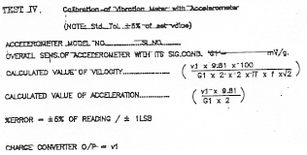

VELOCITY |  |  |  |  | ACCELERATION
Freq.  Hz | O/p  (V1)  p-pmV | Cal.val.  (rms)  Cm/sec | Meas.val.  (rms)  Cm/sec | %  Error | Freq.  Hz | O/p  (V1)  p-pmV | Cal.val.  (pk)  m/sec² | Meas.val.  (pk)  m/sec² | %  Error

DISPLACEMENT |  |  |  |  | DISPLACEMENT
Freq.  Hz | O/p  (V1)  p-pmV | Cal.val.  (p-p)  mm | Meas.val.  (p-p)  mm | %  Error | Freq.  Hz | O/p  (V1)  p-pmV | Cal.val.  (p-p)  mm | Meas.val.  (p-p)  mm | %  Error

TESTED BY: APPROVED BY: HOD – PDN

DATE

Form No. : R/PP-05/10-VM/REV 00 Pg 6 of 6

CHARGE AMPLIFIER TEST RECORD

Customer……………………………………………………………………………… J.O. No……………………………
Model No……………… Sl.No…………………………
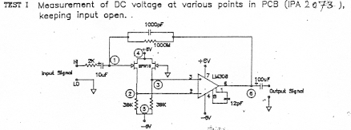
POINTS | TP4 | TP5 | TP6 | TP1 | TP2 | TP7
EXPECTED  DC VOLTAGE (V) | 6.2 to 7.5 | 1<=V<=4 | 1<=V<=4 | +6V to +6.5 | -6V to -6.5 | Max+1V  Min -1V
OBTAINED
DC VOLTAGE (V)

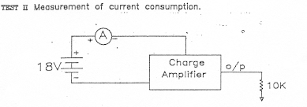

 | EXPECTED CURRENT | OBTAINED CURRENT
With i/p open with 10K load | 3mA± 1mA
With i/p 10V  (p-p) .1 KHz  AC Signal  With 10K load | 3mA± 1mA

TESTED BY: APPROVED BY: HOD – PDN

DATE

Form No. : R/PP-05/11-CA/REV 00 Pg 2 of 7

CHARGE AMPLIFIER TEST RECORD

Customer……………………………………………………………………………… J.O. No……………………………
Model No……………… Sl.No…………………………
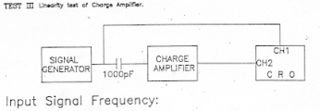

READING TOL. +/- 2%

a) 10 Hz b) 20Hz
SL. No. | I/P Signal  pk-pk | O/P  Signal  Pk-pk
1 | 10mV
2 | 20mV
3 | 50mV
4 | 100mV
5 | 200mV
6 | 500mV
7 | 1V
8 | 2V
9 | 5V
10 | 10V

SL. No. | I/P Signal  pk-pk | O/P  Signal  Pk-pk
1 | 10mV
2 | 20mV
3 | 50mV
4 | 100mV
5 | 200mV
6 | 500mV
7 | 1V
8 | 2V
9 | 5V
10 | 10V

TESTED BY: APPROVED BY: HOD – PDN

DATE

Form No. : R/PP-05/11-CA/REV 00 Pg 3 of 7

CHARGE AMPLIFIER TEST RECORD

Model No……………… Sl.No…………………………

Input Signal Frequency:
c) 50 Hz d) 100Hz
SL. No. | I/P Signal  pk-pk | O/P  Signal  Pk-pk
1 | 10mV
2 | 20mV
3 | 50mV
4 | 100mV
5 | 200mV
6 | 500mV
7 | 1V
8 | 2V
9 | 5V
10 | 10V

SL. No. | I/P Signal  pk-pk | O/P  Signal  Pk-pk
1 | 10mV
2 | 20mV
3 | 50mV
4 | 100mV
5 | 200mV
6 | 500mV
7 | 1V
8 | 2V
9 | 5V
10 | 10V

e) 200 Hz f) 500Hz
SL. No. | I/P Signal  pk-pk | O/P  Signal  Pk-pk
1 | 10mV
2 | 20mV
3 | 50mV
4 | 100mV
5 | 200mV
6 | 500mV
7 | 1V
8 | 2V
9 | 5V
10 | 10V

SL. No. | I/P Signal  pk-pk | O/P  Signal  Pk-pk
1 | 10mV
2 | 20mV
3 | 50mV
4 | 100mV
5 | 200mV
6 | 500mV
7 | 1V
8 | 2V
9 | 5V
10 | 10V

TESTED BY: APPROVED BY: HOD – PDN

DATE

Form No. : R/PP-05/11-CA/REV 00 Pg 4 of 7

CHARGE AMPLIFIER TEST RECORD

Model No……………… Sl.No…………………………

Input Signal Frequency:
g) 1K Hz h) 2K Hz
SL. No. | I/P Signal  pk-pk | O/P  Signal  Pk-pk
1 | 10mV
2 | 20mV
3 | 50mV
4 | 100mV
5 | 200mV
6 | 500mV
7 | 1V
8 | 2V
9 | 5V
10 | 10V

SL. No. | I/P Signal  pk-pk | O/P  Signal  Pk-pk
1 | 10mV
2 | 20mV
3 | 50mV
4 | 100mV
5 | 200mV
6 | 500mV
7 | 1V
8 | 2V
9 | 5V
10 | 10V

i) 5K Hz j) 10K Hz
SL. No. | I/P Signal  pk-pk | O/P  Signal  Pk-pk
1 | 10mV
2 | 20mV
3 | 50mV
4 | 100mV
5 | 200mV
6 | 500mV
7 | 1V
8 | 2V
9 | 5V
10 | 10V

SL. No. | I/P Signal  pk-pk | O/P  Signal  Pk-pk
1 | 10mV
2 | 20mV
3 | 50mV
4 | 100mV
5 | 200mV
6 | 500mV
7 | 1V
8 | 2V
9 | 5V
10 | 10V

TESTED BY: APPROVED BY: HOD – PDN

DATE

Form No. : R/PP-05/11-CA/REV 00 Pg 5 of 7

CHARGE AMPLIFIER TEST RECORD

Model No……………… Sl.No…………………………

TEST IV
Measurement of Maximum Input Signal and
Maximum Output Signal

Maximum Input Signal = ………………………………………………Freq……………………

Maximum Input Signal = ………………………………………………Freq……………………

TEST V Frequency Response of Charge Amplifier
(A) Input Signal = 50 mV pk-pk
READING TOL. ± 2%
Freq.  Hz. | Input Signal  Vi mV pk-pk | Output Signal  Vo mV pk-pk | Gain =  20 log (Vo/Vi)
1 | 50
2 | 50
5 | 50
10 | 50
20 | 50
50 | 50
100 | 50
200 | 50
500 | 50
1K | 50
2K | 50
5K | 50
10K | 50
20K | 50
50K | 50
100K | 50

TESTED BY: APPROVED BY:

DATE HOD – PDN

Form No. : R/PP-05/11-CA/REV 00 Pg 6 of 7

CHARGE AMPLIFIER TEST RECORD

Model No……………… Sl.No…………………………

TEST V (CONTD.)
(B) Input Signal = 10 V pk-pk
READING TOL. ± 2%
Freq.  Hz. | Input Signal  Vi mV pk-pk | Output Signal  Vo mV pk-pk | Gain =  20 log (Vo/Vi)
1 | 10
2 | 10
5 | 10
10 | 10
20 | 10
50 | 10
100 | 10
200 | 10
500 | 10
1K | 10
2K | 10
5K | 10
10K | 10
20K | 10
50K | 10
100K | 10

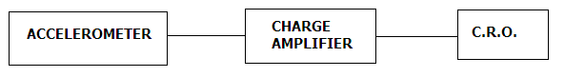
TEST VI Measurement of Noise Level

Accelerometer type………………………… Sl No……………………………..

NOISE LEVEL

TESTED BY: APPROVED BY: HOD – PDN

DATE:

Customer J.O. No.

Form No. : R/PP-05/11-CA/REV 00 Pg 7 of 7

CHARGE AMPLIFIER TEST RECORD

Customer……………………………………………………………………………… J.O. No……………………………

Model No……………… Sl.No…………………………

SPECIFICATION:

A) FREQUENCY RANGE :

B) MAXIMUM INPUT SIGNAL :

C) MAXIMUM OUTPUT SIGNAL :

D) GAIN :

- DIMENSIONS

HEIGHT :

WIDTH :

DEPTH :

TESTED BY: APPROVED BY:

DATE HOD – PDN

Name Signature Designation

Form No. : R/PP-05/11-CA/REV 00 Pg 1 of 7

VIBRATION METER TEST RECORD

Customer……………………………………………………………………………… J.O. No……………………………

Model No……………… Sl.No…………………………

ACCELEROMETER MODEL NO……………………………………… SL No…………………………………………………

ACCURACY

ACCELERATION :

VELOCITY :

DISPLACEMENT :

TESTED BY: APPROVED BY:

DATE HOD – PDN

Form No. : R/PP-05/10-VM/REV 00 Pg 1 of 6

ACCELEROMETER TEST RECORD

Customer……………………………………………………………………………… J.O. No……………………………

Model No……………… Sl.No…………………………

SPECIFICATION:

A) CHARGE SENSITIVITY :

B) CAPACITANCE :

C) LEAKGE RESISTANCE :
At 30ºC , M ohms

D) TRANSVERSE SENSITIVITY :

- CONSTRUCTION : CENTER MOUNTED
COMPRESSION
- TYPE OF CONNECTION : SIDE

- OUTPUT CONNECTOR : 10-32 UNF

- WEIGHT (gms) :

- MOUNTING THREAD : M5

- HEIGHT :

- SPANNER SIZE :

ACCESSORIES STANDARD

LOW NOISE CABLE OF 1 METER LENGTH WITH

10-32 UNF MINIATURE COAXIAL MALE CONNECTOR ( )………………1 No……………

THREADED STEEL STUDS M5 (AS 1001)…………………………………5 NOS.

TESTED BY: APPROVED BY:

DATE HOD – PDN

Form No. : R/PP-05/09-ACC/REV 01 Pg 1 of 3

PERFORMANCE DELAY ANALYSIS
(Production Systems/Production TRS)

MONTH | No. OF JOBS /  LOAD CELLS  SHEDULED | No. OF JOBS /  LOAD CELLS COMPLETED | PERCENTAGE OF DELAY DUE TO
Nov 15 | 62 | 54 | REWORK & REJECTIONS IN | MAN POWER | COMPONENT / MATERIAL STORAGE | PROLONG  TESTING | DESIGN I/P
Nov 15 | 62 | 54 | Nil | Nil | 8.0% | 3.2% | 1.6%
PREPARED BY: APPROVED BY:
HOD : PDN

Form No. : R/PP-05/12/REV 01 Pg 1 of 2

PARTICULARS FOR DELAY ANALYSIS (Production Systems/Production TRS)
MONTH / YEAR: OCT 15

SL.NO. | J.O.NO. | CUSTOMER | DEPARTMENT | REASON
01  02  03  04  05  06  07  08  09  10  11  12 | 405/15  561/15  662/15  359/15  721/15  710/15  590/15  626/15  701/15  710/15  126/15  531/15 | Chemical Constrn  Coromandel Int.  Electromech Matl.  Graduate Agro  Pragati Automation  Ducom  Thyssenkrupp India  UCIL  MPRL  Thyssenkrupp  AG Conveying  Steed Engg. | PDN  PDN  Sub cont  PUR  DSN  PDN  PDN  PDN  PUR  Sub Cont  PUR  DSN | Delay in Mechanical  Delay in Mechanical  Delay in Load cell blank  Delay in procurement of communication card  Delay in Design  Delay in testing  Delay in Load cell  Delay in testing  Delay in Load cell  Delay in enclosure  Delay in Belt procurement  Delay design
TOTAL NO OF JOBS SCHEDULED : 95 Jobs
NO. OF JOBS EXECUTED : 83 Jobs
TOTAL DELAY : 12.6%
PREPARED BY: Arul APPROVED BY:

DATE: 05/ 10/ 15 (HOD PDN)
COPY: 1) CEO
2 MR
3) Planning

Form No. : R/PP-05/12/REV 01 Pg 2 of 2
REWORK DUE TO DESIGN INPUT (Production Systems)
MONTH/YEAR:

SL.No. | J.O.No. | CUSTOMER | SYSTEM / MATERIAL | REASON FOR REWORK | QTY | TIME TAKEN

TOTAL No. OF JOBS SCHEDULED :
No. OF JOBS EXECUTED :
TOTAL DELAY in % :

PREPARED BY: APPROVED BY:
DATE: ( H.O.D PDN)

COPY: 1) MR
- DSN

Form No. : R/PP-05/13/REV 01 Pg 1 of 1

INCOMING MATERIAL REVIEW OF PDN

MONTH: Dec 2012

SL.NO. | JOB No. | CUSTOMER | MAT. DESCRIPTION | NATURE OF NON- CONFORMANCE | REMARKS
01.

COPY TO: 1) Director Technical
2) MR
3) QC

PREPARED BY: APPROVED BY
HOD(PDN)

Form No. : R/PP-05/14/REV 00 Pg 1 of 1

TEST REPORT FOR VIBRATION METER

JOB NO : ACCELEROMETER
CUSTOMER: MODEL NO:
VIBRATION METER SERIAL NO:
MODEL NO:
SERIAL NO:
ACCELERATION  in m/s^2 | VELOCITY  in cm/s | DISPLACEMENT  in mm
STANDARD TESTED | STANDARD TESTED | STANDARD TESTED

TESTED BY: APPROVED BY:
DATE: (HOD-PDN)

Note: This format shall be used when testing and calibration is done using vibration meter standard reference.
Form No: R/PP-05/10-VM –I Rev -00

Test Report for miscellaneous items: Production Systems

Job No: Model No:
Customer: Sl. No:
Item Description : Qty:

_______________________________________________________________________________________

Test Readings and Result:

Tested by: Approved by:
Date: (HOD-PDN)
Form No.: R/PP-05/16 Rev 00 Page 1 of 1

PRODUCTION (Transducer)

DETAIL PRODUCTION PLAN: MONTH:

J.O.No. | Customer | Model | QTY. | DATE |  | REMARKS
 |  |  |  | PLANNED | ACTUAL | REMARKS
PREPARED BY: APPROVED BY:
(PDN-IN-CHARGE) (HOD - PDN)
Form No. : R/PP-05/02/REV 00 Pg 1 of 1
Form No. : R/PP-05/15/REV 00 Pg 1 of 1
TRANSDUCER PRODUCTION PERFORMANCE INDEX YEAR-
MONTH | No. OF LOAD CELLS  SCHEDULED | LOAD CELL PRODUCED |  |  | LOAD CELLS REJECTED
MONTH | No. OF LOAD CELLS  SCHEDULED | TOTAL QTY | EXCESS % | SHORTAGE % | TOTAL QTY | % REJECTION
JAN
FEB
MAR
APR
MAY
JUN
JUL
AUG
SEP
OCT
NOV
DEC
PREPARED BY: APPROVED BY:
IN CHARGE TRS.
(HOD - PDN)

TEST REPORT FOR ACCELEROMETER WITH 4-20 mA OUTPUT

CUSTOMER: MODEL No:
JOB No.: SL No:

1. LIBEARITY TEST: (Ref Freq: 100 Hz)
SL.No | ACCELERATION in “ g” | CURRENT OUTPUT in mA

2. FREQUENCY RESPONSE TEST :
SL.No | FREQUENCY in Hz | ACCELERATION in “g” | CURRENT OUTPUT in mA

TESTED BY : APPROVED BY:
DATE : (H.O.D, PDN)

